***Ministry of power***

*TECHNICAL PROPOSAL*

*FOR*

**Development of Electricity Sector Performance Management System Software and Dashboard**

*SUBMITTED BY*



**Suite C05 Peace Park Plaza A, No. 35 Ajose Adegoun Street, Utako District Abuja**

TABLE OF CONTENTS

CHAPTERS CONTENT PAGE

1. TECHNICAL PROPOSAL SUBMISSION FORM 1

2. CONSULTANT’S ORGANIZATION AND EXPERIENCE 2-8

3. COMMENTS OR SUGGESTIONS ON THE TERMS OF

REFERENCE AND ON COUNTER PART STAFF AND

FACILITIES TO BE PROVIDED BY THE CLIENT 10

4. DESCRIPTION OF THE APPROACH, METHODOLOGY

AND WORK PLAN FOR PERFORMING THE

ASSIGNMENT 11-13

5 WORK SCHEDULE 14-15

6.

TEAM COMPOSITION AND TASK ASSIGNMENT 16-20

7. STAFFING SCHEDULE 21

8. CURRICULUM VITAE (CV) FOR PROPOSED 22-37

PROFESSIONAL STAFF

9. APPENDIX 1.Firm’s organization structure

2. Business Registration certificate

3. 3 Years Audited Accounts for 2016, 2017 & 2018

4. 3 years Tax clearance certificate for 2016, 2017 & 2018

5. Evidence of VAT registration (Color)

6. Profile of the firm

7. Evidence of Compliance with Pension reform act

2004

8. Evidence of Contribution to ITF

9. Details of relevant verifiable experiences on

Similar past projects

10. All relevant information concerning physical

Address and others

11. Evidence of VAT and Tax remittance

FORM – 4A1 TECHNICAL PROPOSAL SUBMISSION FORM

**The Tender Box,**

.

Dear Sir:

We, the undersigned, offer to provide the consulting services to the commission for the **Development of Electricity Sector Performance Management System Software and Dashboard,** in accordance with your request for Proposal dated **2nd September, 2019** and our Proposal. We are hereby submitting our Proposal, which includes the Technical Proposal, and the Financial Proposal sealed under two separate envelopes.

If negotiations are held during the period of validity of the Proposal, i.e., before the date indicated in Clause Reference 25 of the Special Instructions to Consultants, we undertake to negotiate on the basis of the proposed staff. Our Proposal is binding upon us and subject to the modifications resulting from Contract negotiations.

**We undertake, if our Proposal is accepted, to initiate the consulting services related to the assignment not later than the date indicated in Clause Reference 48 of the Special Instructions to Consultants.**

We also confirm that the Federal Government of Nigeria has not declared us, or any sub consultants for any part of the Contract, ineligible on charges of engaging in corrupt, fraudulent, collusive or coercive practices. We furthermore, pledge not to indulge in such practices in competing for or in executing the Contract, and we are aware of the relevant provisions of the Proposal Document (ITC Clause 3).

We understand you are not bound to accept any Proposal you receive.

We remain,

Yours sincerely,

|  |  |
| --- | --- |
| Authorised Signature |  |
| Name and title of Signatory | Mustapha Hussain Olarewaju (FCA)  Managing Consultant/CEO |
| Name of Firm | MHOA & Co. (Chartered Accountants) |
| Address | Plot 481, Utako District, Abuja. |

FORM - 4A2 CONSULTANT’S ORGANIZATION AND EXPERIENCE

1. **BACKGROUND**

MHOA & Co. (Chartered Accountants) was registered for Public Accounting Practice as a business name on May 18, 2006 with the Corporate Affairs Commission (CAC) with registration No. KD024053. As a fast-growing indigenous firm of Chartered Accountants in Nigeria, the firm works with public and private organizations to provide a wide range of services that includes Statutory Audits, Accountancy and Financial Advisory Services, Taxation and Management Consultancy, as well as training in the areas of accountancy and management consultancy.

MHOA & Co (Chartered Accountants) is an indigenous firm of practicing accountants managed by a group of qualified and experienced professionals licensed by the Institute of Chartered Accountants of Nigeria. MHOA & Co (Chartered Accountants) recognizes the important needs of its clients, and is therefore set to provide them with its expertise in this regard. By knowing our clients’ needs, by keeping them foremost in our minds and deeds, by observing the legal and government policy directives and by thoroughly understanding the workings of both local and global economy, we bring to our clients much strength such as: Technical Competence; Highly Trained Professional Personnel; and Effective Quality Control.

**2.0 STRUCTURE OF THE FIRM**

The Professional Services of the Firm are coordinated by FOUR ACTIVE Management Team:

* Mustapha Hussain Olarewaju Managing Partner
* Mallam Suleiman Dan-Iya Umar Technical Partner
* Ameen Abdulrafiu Partner

**2.1 STAFFING**

The Firm has Seven (7) professionally Qualified Accountants and Twelve (12) other staff across the four offices. Each state office is headed by a manager. The Firm’s culture of excellence made it absolutely necessary to recruit the appropriate best staffs that are committed to maintaining the highest technical standards. Our Firm is structured such that our Professional Staff are specialized to handle jobs.

**3.0 EQUIPMENT AND TECHNICAL CAPACITY**

The Firm has invested substantial effort and money in ensuring that all its offices are automated with modern facilities to successfully operate in a competitive Information technology driven environment. All staff have ready access to computers, Scanners, Printers and the Internet. The Firm has a team of Computer Specialists such as System Analyst and Software Development Consultant who are equipped to handle Microsoft Excel, Spread Sheets and Microsoft Word.

Our staff are highly proficient in the Audit of Computer based Accounting Records and many have reached an advanced stage towards obtaining qualification as Professional Certified Information System Auditors (CISA). Additionally, the Firm sends its staff regularly on continuous Professional Education Programmes to update their knowledge and skills.

**4.0 OUR OFFICES**

The Firm, MHOA & CO (Chartered Accountants) has an Associate Organization, Messrs. MHOA Consulting Ltd which is also involved in the provision of Professional Services such as Management Consultancy, Information Technology (IT), and Tax practices. MHOA & CO (Chartered Accountants) including its Associate Organizations have its Head office in Abuja and Branches in other parts of the country. The Head office and branches addresses are as shown below:

|  |
| --- |
| **2.1 ABUJA: Head Office**  Suite C05, 3rd floor, Peace Park Plaza A Plot 481/ No. 35, Ajose Adeogun Street, Utako District, Abuja.  GSM: 08035926194, 08084706777  Email: mhoaconsulting@yahoo.com  Website: [www.mhoaconsulting.com](http://www.mhoaconsulting.com) |
| **2.2 Kaduna office**  Suite IF 108, 5th Floor Turaki Ali House 8/9 Ahmadu Bello way, Kaduna  GSM: 08035926194 |
| **2.3 Kwara office**  No 183, Ibrahim Taiwo Road, Opposite Stadium Complex, Ilorin.  GSM: 07039089400, 08035926194 |

FORM– 4A2 CONSULTANT’S EXPERIENCE A

**SUMMARY LIST OF SIMILAR JOBS DONE IN THE PAST**

|  |  |  |  |  |  |
| --- | --- | --- | --- | --- | --- |
| **S/N** | **Names of Clients** | **Scope/ Nature of Assignment** | **Value** | **Duration** | **Year of Execution** |
|  |  | Consultancy Experience |  |  |  |
| 1 | Commission of Ilorin | Statutory Audit, Taxation and management Consultancy. | ₦9,000,000 | 1 month | 2016/2017 |
| 2 | Kwara State College of education Ilorin | Statutory Audit | ₦3,210,526 | 1 month | 2017 |
| 3 | Nigerian Social Insurance Trust Fund | Statutory Audit of the fund Nationwide | ₦15,000,000 | 8 weeks | 2019 |
| 4 | National Agency for the Control of Aids (NACA) | Statutory Audit of NACA’S Government of Nigeria (GON) Account for the year 2015 | ₦2,000,000 | 2 weeks | 2018 & 2019 |
| 5 | Nigerian Ports Authority | Consultancy Services for the Audit of WACT, FOT ONNE PORT | ₦14,650,000 | 3 Months | 2018 |
| 6 | NNPC Pension Fund Limited | Audit of Premium Pension Limited 2 Account for year 2016 | ₦5,250,000 | 4 weeks | 2017 |
| 7 | NEITI | Implementation of IPSAS Accounting | ₦5,167,575 | 8 weeks | 2019 |

CONSULTANT’S EXPERIENCE

**FIRM’S REFERENCE 1**

|  |  |  |
| --- | --- | --- |
| **Assignment Name:**   * *Statutory Audit, Taxation and management Consultancy.* | | Country: *Nigeria* |
| **Assignment Location**  within the Country: - Kwara State | | Duration of Assignment: *4 Weeks* |
| **Name of Client:**  *Commission of Ilorin* | | No. of Staff: *10 (Ten)* |
| Address: *Commission of Ilorin*. | | No of Staff-Months; One |
| Start Date  (Month/Year): 3rd November 2017 | Completion Date  (Month/Year): 7th December 2017 | Approx. Value of Services  *=N=9,000,000.00* |
| Name of Associated Consultant, If Any:  *N/A* | | No. of Months of Professional  Staff Provided by Associated  Consultant: *N/A* |
| Name of Senior Staff (Project Director/Coordinator, Team Leader) Involved and Functions Performed  *Mustapha Hussain-Engagement Partner:-Preparation of Audit Programme; Review of working Paper Files and Draft Accounts and Report; Discussion of Accounts and Report with Client’s Management/Board of directors; Co-ordination of consultancy work aimed at improving the efficiency and effectiveness of Client’s Internal control.* | | |
| Narrative Description of Project: *To examine and express independent opinion on the Clients Financial Statements and underlying Records. Ensuring Accuracy of client’s Tax Assessments and timelessness in the filling of returns; investigate into discrepancies in Financial Records; Assessing and recommending improvement in the level of efficiency and effectiveness of the Internal Audit Unit* | | |
| 1. *Audit Service, which involves obtaining audit evidence through vouching and verification of client’s transaction, Assets and Liabilities; preparation of computer-based Internal Audit Manual.* | | |

|  |  |
| --- | --- |
| Firm’s Name | MHOA & Co. (Chartered Accountants) |
| Authorized Signature | ----------------------------------------------------------------------------- |

**FIRM’S REFERENCE 2**

|  |  |  |
| --- | --- | --- |
| **Assignment Name:**   * *Statutory Audit* | | Country: *Nigeria* |
| **Assignment Location**  Kwara State | | Duration of Assignment: 1 (Ono) Month |
| **Name of Client:**  *Kwara state College of education Ilorin* | | No. of Staff: *12 (Twelve)* |
| Address: *Kwara state College of education Ilorin* Abuja | | No of Staff - Month; One |
| Start Date  18th May 2017 | Completion Date  2017 | Approx. Value of Services  =N= 3,210,526 |
| Name of Associated Consultant, If Any:  *N/A* | | No. of Months of Professional  Staff Provided by Associated  Consultant: *N/A* |
| Name of Senior Staff (Project Director/Coordinator, Team Leader) Involved and Functions Performed  *Mustapha Hussain-Engagement Partner:-Preparation of Audit Programme; Review of working Paper Files and Draft Accounts and Report; Discussion of Accounts and Report with Client’s Management/Board of directors; Co-ordination of consultancy work aimed at improving the efficiency and effectiveness of Client’s Internal control.* | | |
| Narrative Description of Project: *To examine and express independent opinion on the Clients Accounting Processes. Implementing an Accounting System manual.* | | |

|  |  |
| --- | --- |
| Firm’s Name | MHOA & Co. (Chartered Accountants) |
| Authorized Signature | ----------------------------------------------------------------------------- |

**FIRM’S REFERENCE 3**

|  |  |  |
| --- | --- | --- |
| **Assignment Name:**   * Statutory Audit of NACA’S Government of Nigeria (GON) Account for the year 2018 | | Country: *Nigeria* |
| **Assignment Location**  within the Country: - Abuja | | Duration of Assignment: *Two (2) weeks* |
| **Name of Client:**  National Agency for the Control of Aids (NACA) *- Nigeria* | | No. of Staff: *10 (Ten)* |
| Address: Plot 823, Ralph Shodeinde Street, Central Area, Abuja | | No of Staff-Months; Two (2) weeks |
| Start Date  (Month/Year): September 2016 | Completion Date  (Month/Year): September 2018 | Approx. Value of Services  *=N=2,000,000* |
| Name of Associated Consultant, If Any:  *N/A* | | No. of Months of Professional  Staff Provided by Associated  Auditor: *N/A* |
| Name of Senior Staff (Project Director/Coordinator, Team Leader) Involved and Functions Performed  *Mustapha Hussain-Engagement Partner:-Preparation of Audit Programme; Review of working Paper Files and Draft Accounts and Report; Discussion of Accounts and Report with Client’s Management/Board of directors; Co-ordination of consultancy work aimed at improving the efficiency and effectiveness of Client’s Internal control.* | | |
| Narrative Description of Project: *To examine and express independent opinion on the Clients Financial Statements and underlying Records. Ensuring Accuracy of client’s Tax Assessments and timelessness in the filling of returns; investigate into discrepancies in Financial Records; Assessing and recommending improvement in the level of efficiency and effectiveness of the Internal Audit Unit* | | |
| *Audit Service, which involves obtaining audit evidence through vouching and verification of client’s transaction, Assets and Liabilities; preparation of computer-based Internal Audit Manual.* | | |

|  |  |
| --- | --- |
| Firm’s Name | MHOA & Co. (Chartered Accountants) |
| Authorized Signature | ----------------------------------------------------------------------------- |

**FIRM’S REFERENCE 4**

|  |  |  |
| --- | --- | --- |
| **Assignment Name:**   * Consultancy Services for the Audit of WACT, FOT ONNE PORT | | Country: *Nigeria* |
| **Assignment Location**  Port Harcourt, and Rivers | | Duration of Assignment: 12 *weeks* |
| **Name of Client:**  Nigerian Ports Authority | | No. of Staff: *12 (Twelve)* |
| Address: Nigerian Ports Authority Lagos | | No of Staff-Months; (3) Three |
| Start Date  2018 | Completion Date  2018 | Approx. Value of Services |
| Name of Associated Auditor, If Any:    *N/A* | | No. of Months of Professional  Staff Provided by Associated  Auditor: *N/A* |
| Name of Senior Staff (Project Director/Coordinator, Team Leader) Involved and Functions Performed  *Mustapha Hussain-Engagement Partner:-Preparation of Audit Programme; Review of working Paper Files and Draft Accounts and Report; Discussion of Accounts and Report with Client’s Management/Board of directors; Co-ordination of consultancy work aimed at improving the efficiency and effectiveness of Client’s Internal control.* | | |
| Narrative Description of Project: *To examine and express independent opinion on the Clients Financial Statements and underlying Records. Ensuring Accuracy of client’s Tax Assessments and timelessness in the filling of returns; investigate into discrepancies in Financial Records; Assessing and recommending improvement in the level of efficiency and effectiveness of the Internal Audit Unit* | | |
| *Audit Service, which involves obtaining audit evidence through vouching and verification of client’s transaction, Assets and Liabilities; preparation of computer-based Internal Audit Manual.* | | |

|  |  |
| --- | --- |
| Firm’s Name | MHOA & Co. (Chartered Accountants) |
| Authorized Signature | ----------------------------------------------------------------------------- |

**FIRM’S REFERENCE 5**

|  |  |  |
| --- | --- | --- |
| **Assignment Name:**   * Audit of Premium Pension Limited 2 Account for year 2016 | | Country: *Nigeria* |
| **Assignment Location**  FCT Abuja | | Duration of Assignment: 4 *weeks* |
| **Name of Client:**  NNPC Pension Fund Limited | | No. of Staff: *12 (Twelve)* |
| Address Premium Pension Limited HQ Garki Abuja | | No of Staff-Months; (1) one |
| Start Date  2017 | Completion Date  2017 | Approx. Value of Services  ₦5,250,000 |
| Name of Associated Auditor, If Any:    *N/A* | | No. of Months of Professional  Staff Provided by Associated  Auditor: *N/A* |
| Name of Senior Staff (Project Director/Coordinator, Team Leader) Involved and Functions Performed  *Mustapha Hussain-Engagement Partner:-Preparation of Audit Programme; Review of working Paper Files and Draft Accounts and Report; Discussion of Accounts and Report with Client’s Management/Board of directors; Co-ordination of consultancy work aimed at improving the efficiency and effectiveness of Client’s Internal control.* | | |
| Narrative Description of Project: *To examine and express independent opinion on the Clients Financial Statements and underlying Records. Ensuring Accuracy of client’s Tax Assessments and timelessness in the filling of returns; investigate into discrepancies in Financial Records; Assessing and recommending improvement in the level of efficiency and effectiveness of the Internal Audit Unit* | | |
| *Audit Service, which involves obtaining audit evidence through vouching and verification of client’s transaction, Assets and Liabilities; preparation of computer-based Internal Audit Manual.* | | |

|  |  |
| --- | --- |
| Firm’s Name | MHOA & Co. (Chartered Accountants) |
| Authorized Signature | ----------------------------------------------------------------------------- |

FORM-- 4A3 COMMENTS OR SUGGESTIONS ON THE TERMS OF REFERENCE AND ON COUNTERPART STAFF AND FACILITIES TO BE PROVIDED BY THE CLIENT

**ON THE TERMS OF REFERENCE**

We suggest that risk-based system audit approach is adopted. Enterprise risk framework and design which include planning and organization, diagnostic review, internal control system evaluation, design and documentation of the commission’s system.

Risk based audit implementation will involve defining road maps for each risk area, identifying key risk indicators, defining risk enterprise and strategic risk management process.

**ON COUNTERPART STAFF**

All the facilities that will be required for the conduct for audit of the commission are basically divided into two which are Staffing and Information requirements:

1. Staffing Requirement-
2. Project coordinator is required for necessary pre audit documentations and briefings about the assignment to facilitate deliverables as expected in terms of quality and promptness.
3. Liaison officer is required to assist our field staff on logistics need of the assignment

**ON INFORMATION REQUIREMENT**

Detailed documentation/Information, as listed below, shall be required from Client, for efficient and effective delivery of the engagement.

1. Financial statements prepared should include:
2. Sop of each department
3. List of the external stakeholders
4. SOP of the work process from external stakeholders
5. Sample data from the distribution, transmission and generating sector
6. Sample data from other sources of data needed by the ministrry
7. Availing the current software wwithin the ministtry

FROM-- 4A4 DESCRIPTIONS OF THE APPROACH, METHODOLOGY, AND WORK PLAN FOR PERFORMING THE ASSIGNMENT

**TECHNICAL APPROACH AND METHODOLOGY**

The approach, methodology and work plan for performing the assignment have been developed in line with the objectives of the assignment as stated below:

**Objectives**

To navigate these challenges, utility companies and regulatory bodies require robust mechanisms for performance monitoring and management. A Performance Management System (PMS) allows stakeholders to:

* Track key performance indicators (KPIs)
* Identify inefficiencies and areas for improvement
* Ensure compliance with regulatory standards
* Enhance customer satisfaction through reliable service delivery

**Scope**

The scope of work for this project encompasses several key scope,Below are the detailed components that will be addressed:

1. **Data Integration and Centralization**  
   To create a unified platform that integrates data from various sources within the electricity sector, including generation, transmission, distribution, and customer management systems. This will facilitate comprehensive data analysis and reporting.

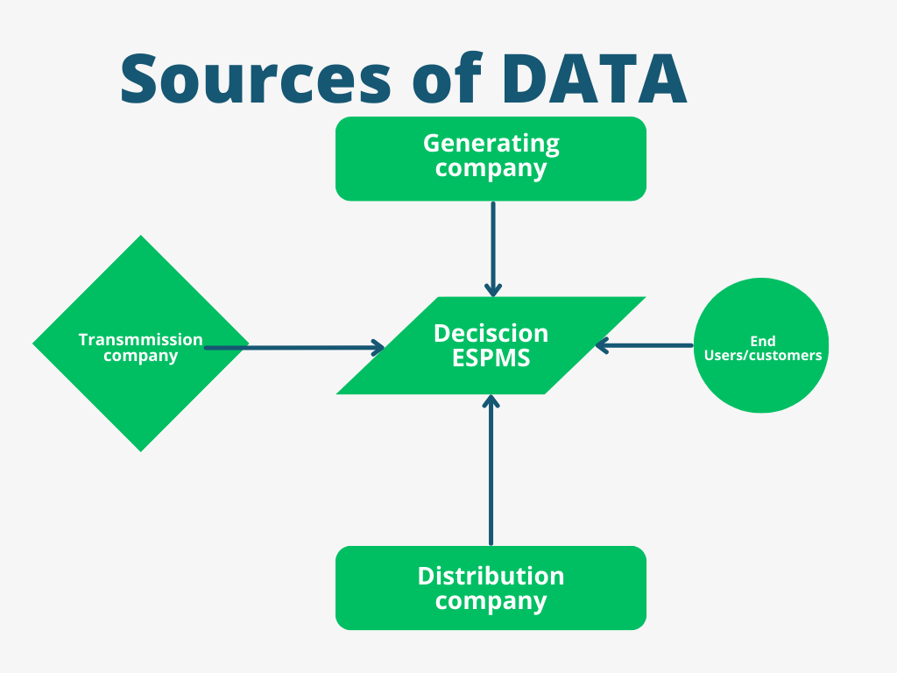

1. **Real-Time Performance Monitoring**  
   To enable real-time tracking of key performance indicators (KPIs) relevant to operational efficiency, reliability, and service quality, allowing stakeholders to make timely decisions based on current performance data.
2. **Enhanced Visualization**  
   To develop an intuitive and user-friendly dashboard that visually represents performance metrics through graphs, charts, and other visual aids, making complex data easily understandable for stakeholders.
3. **Automated Reporting**  
   To implement automated reporting capabilities that generate regular performance reports for various stakeholders, ensuring timely dissemination of information and reducing manual reporting efforts.
4. **Predictive Analytics**  
   To incorporate machine learning and predictive analytics tools that forecast electricity demand, identify trends, and enable proactive decision-making to optimize resource allocation and operational strategies.
5. **Benchmarking and Performance Evaluation**  
   To establish benchmarks for performance evaluation, allowing organizations to compare their performance against industry standards and best practices, facilitating continuous improvement efforts.
6. **Regulatory Compliance**  
   To ensure that the system helps stakeholders maintain compliance with regulatory requirements by providing necessary reports and tracking relevant compliance metrics effectively.
7. **User Engagement and Training**  
   To foster user engagement through training and support, ensuring that all stakeholders can effectively utilize the system, understand its functionalities, and interpret the data presented in the dashboard.
8. **Enhanced Decision-Making**  
   To empower management and operational teams with data-driven insights that support strategic decision-making, leading to improved operational efficiency, resource management, and customer satisfaction.
9. **Scalability and Flexibility**  
   To design a system that is scalable and flexible, accommodating future growth in data volume and evolving needs of the electricity sector, while also allowing for the integration of new technologies as they emerge.

**1. Initiation and Planning**

* **Stakeholder Identification:** Identify all relevant stakeholders (utilities, regulators, consumers).
* **Objective Definition:** Establish clear goals for the PMS, such as improving efficiency, reliability, and customer service.
* **Scope Specification:** Define the functionalities required, including data collection, analysis, reporting, and visualization.

**2. Requirements Gathering**

* **Interviews and Workshops:** Conduct sessions with stakeholders to gather detailed requirements and expectations.
* **Surveys and Questionnaires:** Distribute surveys to collect broader insights from users regarding their needs.
* **Benchmarking:** Analyze similar systems to identify features and best practices.

**APPROACH AND METHODOLOGY TO THE ASSIGNMENT**

The scope of work for this project encompasses several key phases, from initial requirements gathering to deployment and training. Below are the detailed components that will be addressed:

1. **Requirements Analysis**

* **Stakeholder Interviews:** Conduct interviews with various stakeholders (utility companies, regulatory bodies, end-users) to gather functional and non-functional requirements.
* **Documentation:** Create a comprehensive requirements specification document outlining system needs, including desired features, performance metrics, and user roles.

#### 2. **System Design**

* **Architectural Design:** Develop a scalable and modular architecture, leveraging microservices to ensure flexibility and maintainability.
* **Database Design:** Design a relational database (e.g.MySQL) for structured data storage, ensuring data integrity, security, and ease of access.
* **User Interface Design:** Create wireframes and prototypes for the user interface/dashbpoards for all ther stakehpolders, focusing on usability and user experience.

3. **Software Development**

* **Back-End Development:** Implement the server-side logic, APIs, and data processing components necessary for the system to function effectively.
* **Front-End Development:** Develop the client-side interface, ensuring it is responsive and user-friendly across devices.
* **Integration:** Facilitate integration with existing systems (e.g.ERP) to ensure seamless data flow and functionality.

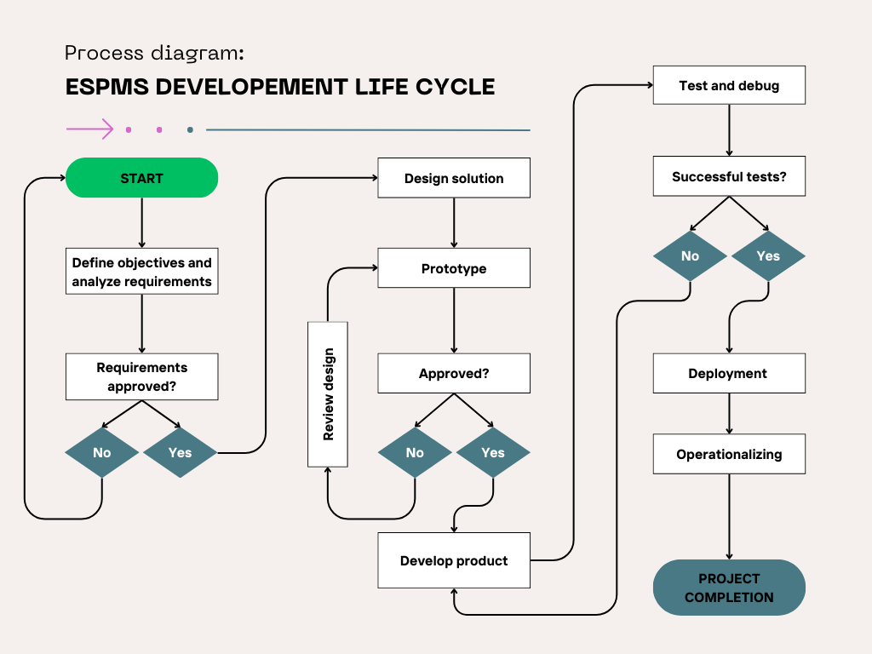

4. **Dashboard Development**

* **KPI Identification:** Collaborate with stakeholders to define key performance indicators critical for monitoring and reporting.
* **Data Visualization:** Utilize visualization libraries (e.g., D3.js, Chart.js) to create interactive and dynamic dashboards that present data intuitively.
* **Custom Reporting Tools:** Develop tools that allow users to create custom reports based on specific metrics and timeframes.

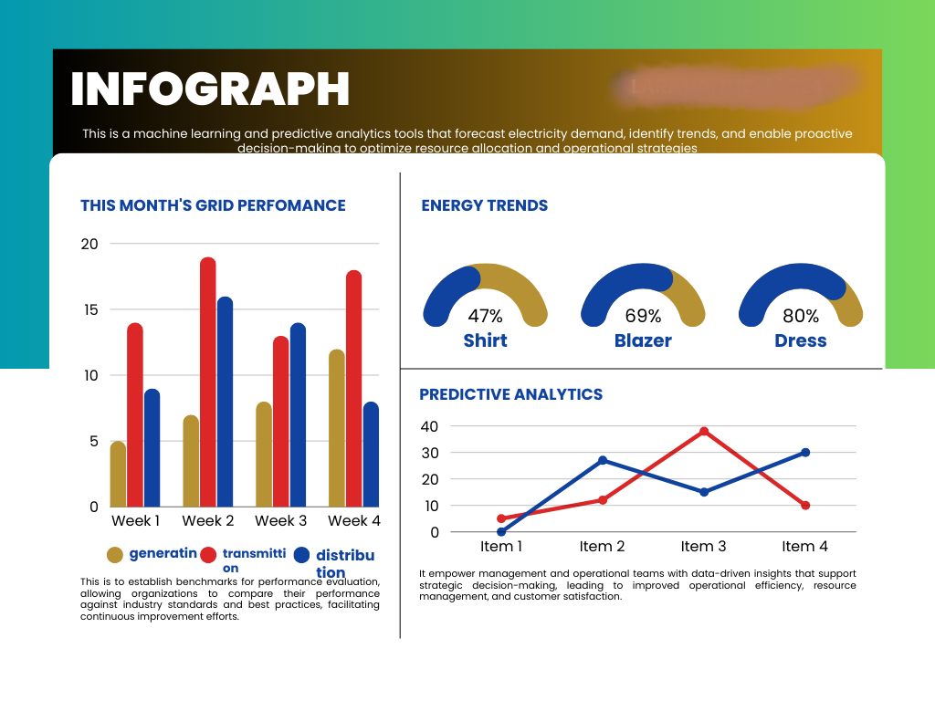

5. **Testing and Quality Assurance**

* **Testing Plan Development:** Create a comprehensive testing strategy that includes unit tests, integration tests, and user acceptance testing (UAT).
* **Data migration and Execution of Tests:** Conduct rigorous testing to identify and resolve any bugs or issues prior to deployment, ensuring system reliability and performance.
* **Feedback Loop:** Implement a feedback loop with stakeholders during testing to ensure the system meets user needs.

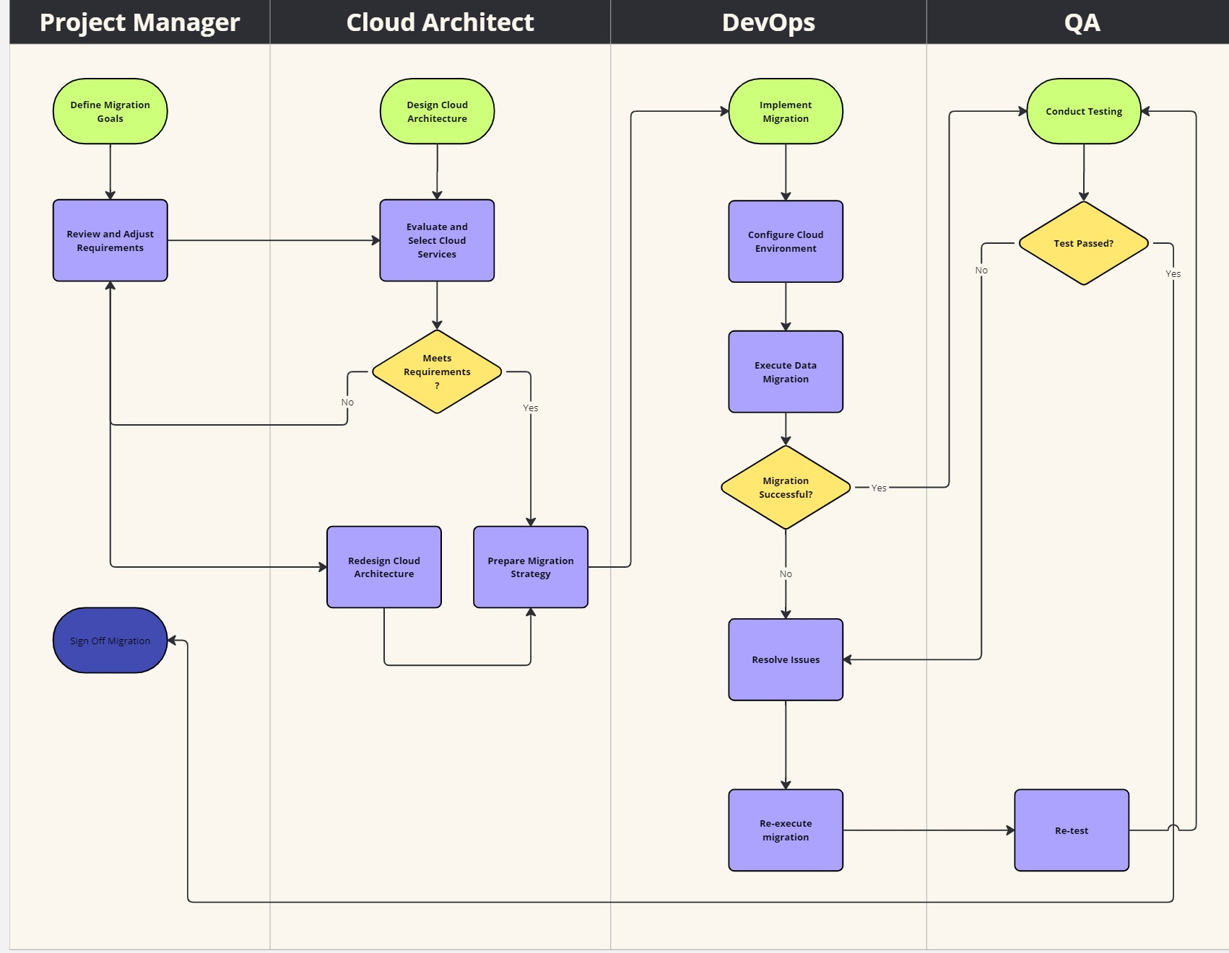

#### 6. **Deployment**

* **Phased Rollout:** Implement a phased deployment strategy to minimize risks, starting with a pilot phase before full-scale deployment.
* **Cloud or On-Premises Setup:** Determine the deployment environment (cloud-based or on-premises) based on stakeholder requirements and infrastructure capabilities.

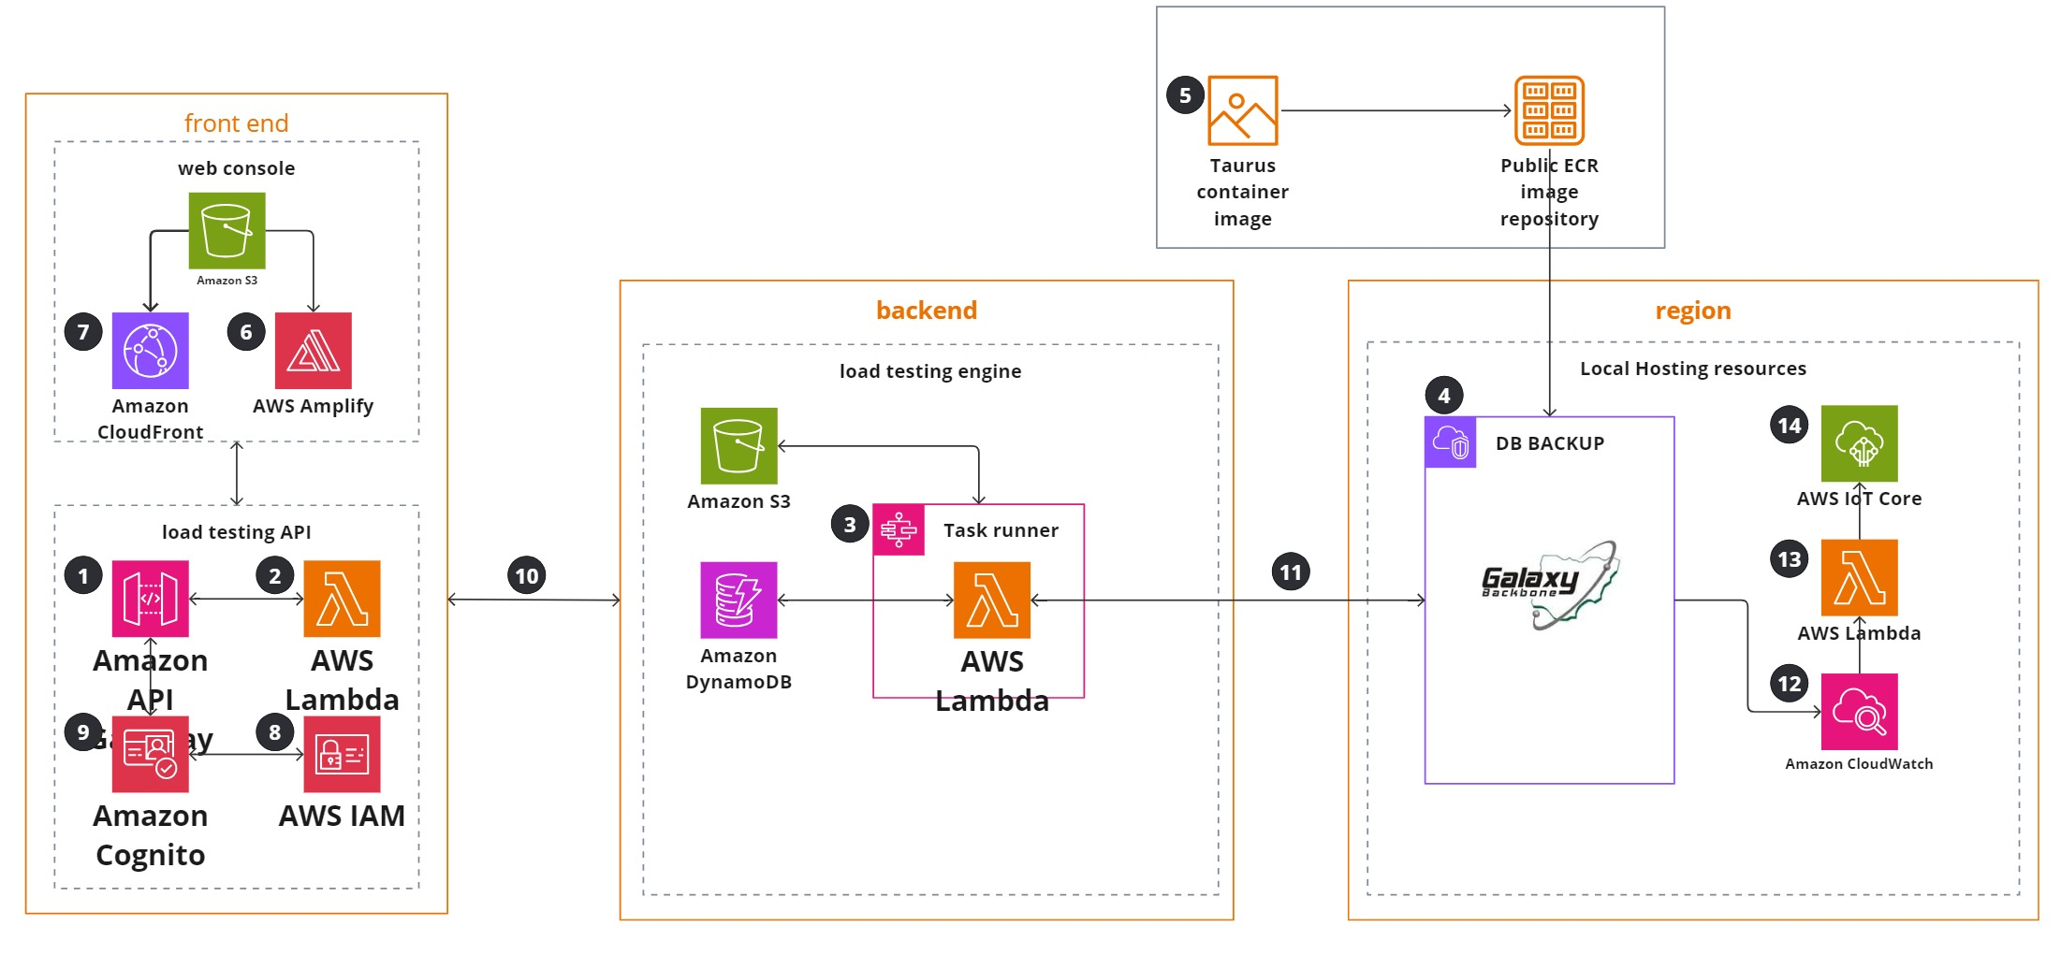

#### 7. **Training and Support**

* **User Training:** Provide comprehensive training sessions for end-users to familiarize them with the system's functionalities and features.
* **Documentation:** Develop user manuals and online help resources to assist users in navigating the system effectively.
* **Ongoing Support:** Establish a support mechanism for users to report issues and receive assistance post-deployment.

#### 8. **Post-Deployment Evaluation**

* **Performance Monitoring:** Implement mechanisms to continuously monitor system performance and user engagement after deployment.
* **Feedback Collection:** Regularly collect user feedback to identify areas for improvement and feature enhancement

WORK PLAN

The work plan is comprised of sequence of activities, contents, phasing, period and deliverables of activities. The plan relates the above variables to achievement of the objective of the Audit.

| Activities | Details | Deliverables | Timeline (weeks) | Responsibility |
| --- | --- | --- | --- | --- |
| 1.Planning | * The Planning phase fosters effective communication and collaboration within the team. By defining clear roles, responsibilities, and expectations, it lays a solid foundation for an efficient software development process Methodology, Ascertain terms of the engagement * Determine team skills and competence * Understand the entity’s business * Understand entity wide internal control and the risk of fraud * Obtain high-level understanding of the ESPMS system | * Inception meeting and report | 2 weeks | Consultants/Clients |
| 2. Requirement Analysis | Requirements Analysis, seeks to identify and record the precise requirements of the final users. In this phase, the team is looking to answer, “What are the expectations of our users from our software?” This is called requirements gathering.  The project team collects information from stakeholders, including analysts, users, and clients. They conduct interviews, surveys, and focus groups to understand the user’s expectations and needs. The process involves not only asking the right questions but also accurately interpreting the responses.  After collecting the data, the team analyzes it, distinguishing the essential features from the desirable ones. This analysis helps the team understand the software’s functionality, performance, security, and interface needs.  These efforts result in a Requirements Specification Document. It outlines the software’s purpose, features, and functionalities, acting as a guide for the development team and providing cost estimates if needed. To ensure its reliability, the document is validated for accuracy, comprehensiveness, and feasibility.  The success of the Requirements Analysis phase is pivotal for the entire project. Done right, it leads to a software solution that meets users’ needs and exceeds their expectations. | * Field Work * Draft report   Both Hard and Soft Copies | 2weeks | Consultants |
| 3. design | The Design phase is the link between the software’s purpose (established in the Planning and Requirements Analysis phases) and its execution (defined in the coding phase). It’s an essential step in creating software that works efficiently and provides an excellent user experience. This involves;   * Different Designing Tools * The Architectural Design * Model Design * System Interaction Design * Db Design * Security Architecture * Components Diagram * Server Architectur | * Final report * Both Hard and Soft Copies | 2 weeks | Project Team and client |
| 4. development | This development phase aims to develop software that is functional, efficient, and user-friendly. Developers use an appropriate programming language, Java or otherwise, to write the code, guided by the SDD and coding guidelines. This document, acting as a roadmap, ensures the software aligns with the vision set in earlier phases.  Another key aspect of this phase is regular code reviews. Team members carefully examine each other’s work to identify any bugs or inconsistencies. These meticulous assessments uphold high code standards, ensuring the software’s reliability and robustness. This phase also includes preliminary internal testing to confirm the software’s basic functionality.  At the end of this phase, a functional piece of software comes to life. It embodies the planning, analyzing, and designing efforts of the preceding stages. Though it may not be flawless, it represents a significant stride towards a valuable software solution. |  | 6-weeks | consultant |
| 4.Testing | Software testing involves a thorough examination of the software for any bugs or glitches that might have slipped through during coding. The aim is to ensure flawless software operation before it reaches the end-users. And even identify opportunities for enhancement.  The testing process begins by setting clear parameters in line with the software’s requirements. This includes identifying the necessary software conditions, and outlining diverse scenarios to examine these conditions. This step aids in creating an efficient testing strategy.  **THE DIFFERENT TYPES OF TESTS to be conducted are**   * Unit tests. Unit tests are very low level and close to the source of an application. ... * Integration tests. ... * Functional tests. ... * End-to-end tests. ... * Acceptance testing. ... * Performance testing. |  |  |  |
| 6.deployment | The Deployment phase involves rolling out the meticulously tested and fine-tuned software to its end-users.  A specific strategy is executed for the software’s deployment to ensure minimal disruption to the user experience. Depending on the software and its audience, we might use different methods such as Big Bang, Blue-Green,  However, deployment isn’t just about launching the software. It’s about ensuring users can operate it with ease. This responsibility involve creating user manuals, conducting training sessions, offering on-site support.  The Deployment phase doesn’t signal the end, but rather a notable milestone. It signifies the shift from a project phase to a product phase, where the software begins to fulfill its purpose. |  |  |  |
| 7.maintenance and support | The primary focus is to adapt to the software’s changing needs. This adaptation involves responding to user feedback, resolving unexpected issues, and upgrading the software based on users’ evolving requirements. It’s a continuous process of refining and adapting, much like a gardener tending to their garden.  this encompass frequent software updates, implementing patches, and fixing bugs. User support is also a crucial component, offering help and guidance to users facing difficulties with the software. |  |  |  |

FORM 4A5 WORK SCHEDULE

|  |  |  |  |  |  |  |  |  |  |  |  |  |  |  |  |
| --- | --- | --- | --- | --- | --- | --- | --- | --- | --- | --- | --- | --- | --- | --- | --- |
| **N°** | **Activity**1 | **Staff Months** | | | | | | | | | | | | | |
| **0.25**  **1** | **0.25**  **2** | **0.25**  **3** | **0.25**  **4** | **0.25**  **5** | **0.25**  **6** | **0.25**  **7** | **0.25**  **8** | **0.25**  **9** | **0.25**  **10** | **11** | **12** | **n** |
| 1 | Project scope and planning |  |  |  |  |  |  |  |  |  |  |  |  |  |
| 2 | Inception Meeting with the clients |  |  |  |  |  |  |  |  |  |  |  |  |  |
| 3 | Inception report |  |  |  |  |  |  |  |  |  |  |  |  |  |
| 4 | Fact/data/info analysis and interpretation |  |  |  |  |  |  |  |  |  |  |  |  |  |
| 5 | Draft Reporting |  |  |  |  |  |  |  |  |  |  |  |  |  |
| 6 | Final Report |  |  |  |  |  |  |  |  |  |  |  |  |  |

KEY Indicates commencement and ending of Activity

The months have been converted to physical week as shown below

4 weeks = 1 staff months

1 week = ¼ or 0.25 staff months

|  |  |  |
| --- | --- | --- |
| **N°** | **Activity**1 | **Staff Months** |
| 1 | Project scope and planning | 0.25 |
| 2 | Inception Meeting with the clients |
| 3 | Inception report | 0.25 |
| 4 | Fact/data/info analysis and interpretation | 0.75 |
| 5 | Draft Reporting | 0.5 |
| 6 | Final Report | 0.25 |
| Total | | 2.0 |

**BASIS OF COMPUTING PROFESSIONAL STAFF-**

**MONTHS**

If:

1 Staff month = 4 weeks

Then:

0.25 Staff month = 1 week

0.5 Staff month = 2 weeks

WORK SCHEDULE CHART

|  |  |  |  |  |  |  |  |  |
| --- | --- | --- | --- | --- | --- | --- | --- | --- |
| FORM 4A6 TEAM COMPOSITION AND TASK ASSIGNMENTS | | | | | | | | |
| **Professional Staff** | | | | | | | | |
| Name of Staff | | Firm | | Area of Expertise | | Position Assigned | | Task Assigned |
| Mustapha Hussain Olarewaju | | MHOA & CO | | Statutory Audit | | Engagement Partner/Project Manager | | * Project scope and planning * Inception Meeting with the clients * Inception report * Draft Reporting * Final Report |
| Abdulrasaq Mustapha | | MHOA & CO | | Statutory Audit | | Technical Partner/Assistance Project Manager | | * Project scope and planning * Inception Meeting with the clients * Inception report * Fact/data/info analysis and interpretation * Draft Reporting * Final Report |
| Mubaraq Sanni | | MHOA & CO | | Statutory Audit | | Audit Senior/ Accountant | | * Project scope and planning * Inception Meeting with the clients * Inception report * Fact/data/info analysis and interpretation * Draft Reporting * Final Report |
| Ameen Rafiu | | MHOA & CO | | Finance and Accounts | | Audit Senior/ Accountant | | * Project scope and planning * Inception Meeting with the clients * Inception report * Fact/data/info analysis and interpretation * Draft Reporting * Final Report |
| Olaitan Olagoke | | MHOA & CO | | Tax Management | | Audit Senior/ Accountant | | * Fact/data/info analysis and interpretation * Draft Reporting * Final Report |
| Biodun Oyebanji | | MHOA & CO | | Finance and Accounts | | Audit Senior/ Accountant | | * Fact/data/info analysis and interpretation * Draft Reporting * Final Report |
| Ismaila Nasir Ahmed | | MHOA & CO | | ICT/Computer | | ICT/Computer Specialist | | * Fact/data/info analysis and interpretation * Draft Reporting |
| Idris Mohammed | | MHOA & CO | | ICT/Computer | | ICT/Computer Specialist | | * Inception report * Fact/data/info analysis and interpretation * Draft Reporting * Final Report |
| **Support Staff** | | | | | | | | |
| Name of Staff | Firm | | Area of Expertise | | Position Assigned | | Task Assigned | |
| Adeshina Adeoye Sunday | MHOA & CO | | Tech Assistant | | Support Staff | | To assist in data gathering and analysis and logistics | |

|  |  |  |  |  |
| --- | --- | --- | --- | --- |
| **S/No** | **MANAGERIAL/**  **TECHNICAL STAFF** | **PROFESSIONAL QUALIFICATION** | **YEARS OF EXPERIENC** | **STATUS** |
| **1** | Mustapha Hussain Olarewaju | FCA, ACTI, MBA, ACTI | 18 | Engagement Partner/Project Manager |
| **2** | Abdulrasaq Mustapha | M.Sc, B.Sc, ACA | 18 | Technical Partner/Assistant Project Manager |
| **3** | Mubaraq Sanni | Ph.D, M.Sc, B.Sc, ACA | 23 | Audit Senior/ Accountant |
| **4** | Ameen Rafiu | HND, ACA | 18 | Audit Senior/ Accountant |
| **5** | Olaitan Olagoke | HND, ACA | 18 | Audit Senior/ Accountant |
| **6** | Biodun Oyebanji | CNA, PGDM, HND | 18 | Audit Senior/ Accountant |
| **7** | Ismaila Nasir Ahmed | B.Sc, IADC, HSC, CCNA, V-SAT-ESI, | 4 | ICT/Computer Specialist |
| **8** | Idris Mohammed | B.Sc, DCA, | 5 | ICT/Computer Specialist |
|  | **SUPPORTING STAFF** |  |  |  |
| **9** | Adeshina Adeoye Sunday | HND, ACA | 7 | Support |

TEAM COMPOSITION

FORM 4A7 STAFFING SCHEDULE 1

|  |  |  |  |  |  |  |  |  |  |  |  |  |  |  |  |  |  |
| --- | --- | --- | --- | --- | --- | --- | --- | --- | --- | --- | --- | --- | --- | --- | --- | --- | --- |
| N° | **Name of Staff** | Staff-month input by month**1** | | | | | | | | | | | | | Total staff-month input | | |
| **0.25**  **1** | **0.25**  **2** | **0.25**  **3** | **0.25**  **4** | **0.25**  **5** | **0.25**  **6** | **0.25**  **7** | **0.25**  **8** | **0.25**  **9** | **0.25**  **10** | **0.25**  **11** | **12** | **n** | **Home** | **Field**2 | **Total** |
| 1 | **Mustapha Hussain Olarewaju** |  |  |  |  |  |  |  |  |  |  |  |  |  | 0.75 | 0.25 | 1 |
|  |  |  |  |  |  |  |  |  |  |  |  |  |  |  |
| 2 | **Ameen Rafiu** |  |  |  |  |  |  |  |  |  |  |  |  |  | 0.5 | 1.75 | 2.25 |
|  |  |  |  |  |  |  |  |  |  |  |  |  |  |  |
| 3 | **Olaitan Olagoke** |  |  |  |  |  |  |  |  |  |  |  |  |  | 0.5 | 1.75 | 2.25 |
|  |  |  |  |  |  |  |  |  |  |  |  |  |  |  |
| 4 | **Idris Mohammed** |  |  |  |  |  |  |  |  |  |  |  |  |  | 0 | 1.25 | 1.25 |
|  |  |  |  |  |  |  |  |  |  |  |  |  |  |  |
| 5 | **Ismaila Nasir Ahmed** |  |  |  |  |  |  |  |  |  |  |  |  |  | 0 | 1.25 | 1.25 |
|  |  |  |  |  |  |  |  |  |  |  |  |  |  |  |
| 6 | **Biodun Oyebanji** |  |  |  |  |  |  |  |  |  |  |  |  |  | 0.5 | 1.75 | 2.25 |
|  |  |  |  |  |  |  |  |  |  |  |  |  |  |  |
| 7 | **Mubaraq Sanni** |  |  |  |  |  |  |  |  |  |  |  |  |  | 0.5 | 1.75 | 2.25 |
|  |  |  |  |  |  |  |  |  |  |  |  |  |  |  |
| 8 | **Abdulrasaq Mustapha** |  |  |  |  |  |  |  |  |  |  |  |  |  | 0.5 | 1.75 | 2.25 |
|  |  |  |  |  |  |  |  |  |  |  |  |  |  |  |
| 9 | **Adeshina Adeoye** |  |  |  |  |  |  |  |  |  |  |  |  |  |  |  |  |
|  |  |  |  |  |  |  |  |  |  |  |  |  |  |  |
|  |  |  |  |  |  |  |  |  |  |  | **Total** | | | | 3.25 | 11.25 | 14.5 |

KEY Indicates commencement and ending of Activity

The months have been converted to physical week as shown below

4 weeks = 1 staff months

1 week = ¼ or 0.25 staff months

FORM 4A8 CURRICULUM VITAE (CV) FOR EACH PROPOSED PROFESSIONAL STAFF

|  |
| --- |
| 1. Proposed Position Project Manager 2. Name of Person **Mustapha Hussain Olarewaju** 3. Date of Birth 1976 4. Nationality Nigerian |
| 1. Membership In Professional Society   Fellow -Institute of Chartered Accountants of Nig. **(FCA).**  Associate -Chartered Institute of Taxation of Nig. **(FCTI).**  6.Education Commission of Ilorin (MBA)  Kwara State Polytechnic Ilorin (OND & HND  Mount camel college Ilorin (SSCE)    7. Other Training Articleship with Messrs. Mu’Allahyidi & CO,  Internal Control Mgr with First Bank of Nigeria Plc, Lagos.  Managing Partner-MHOA & Co. (Chartered Accountants)  8. Language & Degree of Proficiency **Language Speaking Reading Writing**  English Fluent Excellent Excellent  Yoruba Fluent Excellent Excellent  9.Countries of Work Experience Nigeria |
| 10. **Employment Record**  Mhoa & Co. (Chartered Accountant) Managing Partner 2009 To date  Onireke Farms Director 2009 To date  First Bank of Nigeria Plc. Internal Auditor 2005 To date  Mu Allahyidi & Co. Audit Manager 2002 To date  Morning Star Teacher (NYSC) 2000  Mu Allahyidi & Co. I. T Staff 1996 To 1997 |
| 11. Work Undertaken**:**   * Conversion of the Accounting System to IPSAS Accrual compliant and Training of Account Staff on the IPSAS Accrual Financial Statements at OSGF * Business Process Review and evaluate the current accounting and financial system with a view to identifying gaps, needs and preparedness for conversion and migration to IPSAS accounting framework   Develop an internal IPSAS Reporting Guidebook for the OSGF in line with the implementation roadmap   * Implementation of the accounting system to IPSAS accrual compliant and Training of Account Staff on the IPSAS Accrual Financial Statements at National Arbitration Panel * IPSAS conversion Implementation and Training workshop for Account and internal audit staff on the IPSAS Accrual Financial Statements at Ministry Of Finance – Kaduna |

CERTIFICATION *[Do not amend this Certification].*

I, the undersigned, certify that (i) I was not a former employee of the Client immediately before the submission of this proposal, and (iii) to the best of my knowledge and belief, this biodata correctly describes myself, my qualifications, and my experience. I understand that any wilful mis-statement described herein may lead to my disqualification or dismissal, if engaged.

I have been employed by [*name of the Consultant*] continuously for the last twelve (12) months as regular full-time staff. Indicate “Yes” or “No” in the boxes below:

|  |  |  |  |  |  |  |  |  |  |  |  |  |  |  |  |
| --- | --- | --- | --- | --- | --- | --- | --- | --- | --- | --- | --- | --- | --- | --- | --- |
|  |  |  | **YES** |  |  |  | **NO** |  |  |  |  |  |  |  |  |

|  |  |
| --- | --- |
| Signature |  |
| Date of Signing | Day / Month / Year |

|  |
| --- |
| 1. Proposed Position for this project Assistant Project Manager 2. Name of Person **Mustapha Abdul-rasaq** 3. Date of Birth 11th February 1974 4. Nationality Nigerian |
| 1. Membership in Professional Society Associate Member of Institute of Chartered Accountant   Of Nigeria (ICAN) 2012  6.Education PH.D (Accounting)  M.Sc (Accounting)  Commission of Ilorin (2010)  B.Sc (Accounting)  Commission of Ilorin (2000)  7. Other Training - Impact of Tax Touting on Interstate Road Transport Service Delivery in  in Kwara State. – 2016.  - Impact of Corporate Governance Mechanism on Corporate Tax  Aggressiveness (2016).  - Empirical Evaluation of Contemporary Performance Measurement Practice  In Nigeria (2016).  - Expectation Gap on the internal Auditor’s Role in Nigerian Public Universities (2016).    8. Language & Degree of Proficiency Language Speaking Reading Writing  English Fluent Excellent Excellent  Hausa Fluent Excellent Excellent  Kanuri Fluent Excellent Excellent  9.Countries of Work Experience Nigeria |
| 10. **Employment Record**  Mhoa & Co. (Chartered Accountant) Senior Consultant 2010 – Till date  Kwara State Commission Ilorin Senior Lecturer 2010 - Till date |
| 11. Work Undertaken**:**   * Conversion of the Accounting System to IPSAS Accrual compliant and Training of Account Staff on the IPSAS Accrual Financial Statements at OSGF * Business Process Review and evaluate the current accounting and financial system with a view to identifying gaps, needs and preparedness for conversion and migration to IPSAS accounting framework   Develop an internal IPSAS Reporting Guidebook for the OSGF in line with the implementation roadmap   * Implementation of the accounting system to IPSAS accrual compliant and Training of Account Staff on the IPSAS Accrual Financial Statements at National Arbitration Panel * IPSAS conversion Implementation and Training workshop for Account and internal audit staff on the IPSAS Accrual Financial Statements at Ministry of Finance – Kaduna |

CERTIFICATION *[Do not amend this Certification].*

I, the undersigned, certify that (i) I was not a former employee of the Client immediately before the submission of this proposal, and (iii) to the best of my knowledge and belief, this biodata correctly describes myself, my qualifications, and my experience. I understand that any wilful mis-statement described herein may lead to my disqualification or dismissal, if engaged.

I have been employed by [*name of the Consultant*] continuously for the last twelve (12) months as regular full time staff. Indicate “Yes” or “No” in the boxes below:

|  |  |  |  |  |  |  |  |  |  |  |  |  |  |  |  |
| --- | --- | --- | --- | --- | --- | --- | --- | --- | --- | --- | --- | --- | --- | --- | --- |
|  |  |  | **YES** |  |  |  | **NO** |  |  |  |  |  |  |  |  |

|  |  |
| --- | --- |
| Signature |  |
| Date of Signing | Day / Month / Year |

|  |
| --- |
| 1. Proposed Position for this project Senior Accountant 2. Name of Person **Mubaraq Sanni** 3. Place of Birth Ilorin, Kwara State 4. Nationality Nigerian |
| 1. Membership In Professional Society Associate -Institute of Chartered Accountants of Nig.   **(ACA).**  Associate -Chartered Institute of Taxation of Nig. **(FCTI).**  6.Education International Islamic Commission, Malaysia 2012  PH.D ( Accounting)  Commission of Ilorin, Kwara State  M.Sc (Accounting)  Ahmadu Bello Commission Zaria, Kaduna State  B.Sc (Accounting)  7. Other Training Senior Partner-MHOA & Co. (Chartered Accountants)  8. Language & Degree of Proficiency Language Speaking Reading Writing  English Fluent Excellent Excellent  Yoruba Fluent Excellent Excellent  9.Countries of Work Experience Nigeria |
| 10. **Employment Record**  Mhoa& Co. (Chartered Accountant) Senior Consultant 2010 To date  Kwara State Commission Ilorin Senior Lecturer 2010 To date |
| 11. Work Undertaken**:**   * Provide mentoring, training and support to the agency to ensure a smooth practical application of IPSAS compliant reporting at OSGF * Review and upgrade of the existing accounting manual and align it with IPSAS guidelines at OSGF. * Fully implement the system and processes designed as mentioned in system and process design stage at National Arbitration Panel * IPSAS conversion Implementation and Training workshop for Account and internal audit staff on the IPSAS Accrual Financial Statements at Ministry Of Finance – Kaduna * Develop an internal IPSAS Reporting Guidebook for the agency, in line with the implementation |

CERTIFICATION *[Do not amend this Certification].*

I, the undersigned, certify that (i) I was not a former employee of the Client immediately before the submission of this proposal, and (iii) to the best of my knowledge and belief, this bio data correctly describes myself, my qualifications, and my experience. I understand that any wilful mis-statement described herein may lead to my disqualification or dismissal, if engaged.

I have been employed by [*name of the Consultant*] continuously for the last twelve (12) months as regular full time staff. Indicate “Yes” or “No” in the boxes below:

|  |  |  |  |  |  |  |  |  |  |  |  |  |  |  |  |
| --- | --- | --- | --- | --- | --- | --- | --- | --- | --- | --- | --- | --- | --- | --- | --- |
|  |  |  | **YES** |  |  |  | **NO** |  |  |  |  |  |  |  |  |

|  |  |
| --- | --- |
| Signature |  |
| Date of Signing | Day / Month / Year |

|  |
| --- |
| 1. Proposed Position for this project Consultant 2. Name of Person **Oyebanji Abiodun Yahaya** 3. Date of Birth 1975 4. Nationality Nigerian |
| 5.Membership in Professional Society Certified National Accountant **(ANAN)**  6.Education Nigeria Defence Academy Kaduna 2013  Nigeria College of Accounting Jos 2005  Kaduna State Polytechnic 1999    7. Other Training Articleship with Messrs. Mu’Allahyidi & CO,  8. Language & Degree of Proficiency Language Speaking Reading Writing  English Fluent Excellent Excellent  Yoruba Fluent Excellent Excellent  Hausa Fluent Excellent Excellent  9.Countries of Work Experience Nigeria |
| 10. **Employment Record**  Mhoa & Co.Kaduna (Chartered Accountants) Technical Partner 2010 to Date  HAD Audit, Kaduna (Chartered Accountants) Financial Controller 2005 to 2010  Sulaimon & Co. (Chartered Accountants) Audit Senior 2002 to 2004  Ministry of Financial Dutse 2000 to 2001  Mu’Allayidi & Co Kaduna (Chartered Accountants) 1996 to 1997 |
| 11. Work Undertaken**:**   * IPSAS conversion Implementation and Training workshop for Account and internal audit staff on the IPSAS Accrual Financial Statements at Ministry of Finance – Kaduna * Provide mentoring, training and support to the agency to ensure a smooth practical application of IPSAS compliant reporting at OSGF * Review and upgrade of the existing accounting manual and align it with IPSAS guidelines at OSGF. * Fully implement the system and processes designed as mentioned in system and process design stage at National Arbitration Panel * IPSAS conversion Implementation and Training workshop for Account and internal audit staff on the IPSAS Accrual Financial Statements at Ministry of Finance |

CERTIFICATION *[Do not amend this Certification].*

I, the undersigned, certify that (i) I was not a former employee of the Client immediately before the submission of this proposal, and (iii) to the best of my knowledge and belief, this bio data correctly describes myself, my qualifications, and my experience. I understand that any wilful mis-statement described herein may lead to my disqualification or dismissal, if engaged.

I have been employed by [*name of the Consultant*] continuously for the last twelve (12) months as regular full time staff. Indicate “Yes” or “No” in the boxes below:

|  |  |  |  |  |  |  |  |  |  |  |  |  |  |  |  |
| --- | --- | --- | --- | --- | --- | --- | --- | --- | --- | --- | --- | --- | --- | --- | --- |
|  |  |  | **YES** |  |  |  | **NO** |  |  |  |  |  |  |  |  |

|  |  |
| --- | --- |
| Signature |  |
| Date of Signing | Day / Month / Year |

|  |
| --- |
| 1. Proposed Position for this project Consultant 2. Name of Person **AMEEN ABDULRAFIU AJADI** 3. Date of Birth 26th November, 1976 4. Nationality Nigerian |
| 1. Membership in Professional Society Associate Member of ICAN (2006) 2. Education Master Degree in Business Administration (2012)   HND Accountancy (Lower Credit), 2000  OND Financial Studies (Upper Credit), 1997  Senior School Certificate Examination (SSCE) 1993  Primary School Leaving Certificate (1987)  7. Other Training        8. Language & Degree of Proficiency Language Speaking Reading Writing  English Fluent Excellent Excellent  Yoruba Fluent Excellent Excellent    9. Countries of Work Experience Nigeria |
| 10. **Employment Record**  Mhoa & Co.( Chartered Accountant) Consultant 2012 till Date  Access Bank Plc, Nigeria Internal Control 2008 to 2012  Mu’ Allayidi & Co. Consultant March 2005 to 2008  Ubala Abah & Co. Consultant April 2004 to March 2005  Havard Security Company Ltd Consultant Sept. 2001 to March 2004  International Tanners Ltd Account dept. (NYSC) 2000 to 2001 |
| 11. Work Undertaken**:**   * IPSAS conversion Implementation and Training workshop for Account and internal audit staff on the IPSAS Accrual Financial Statements at Ministry Of Finance – Kaduna * Provide mentoring, training and support to the agency to ensure a smooth practical application of IPSAS compliant reporting at OSGF * Review and upgrade of the existing accounting manual and align it with IPSAS guidelines at OSGF. * Fully implement the system and processes designed as mentioned in system and process design stage at National Arbitration Panel * IPSAS conversion Implementation and Training workshop for Account and internal audit staff on the IPSAS Accrual Financial Statements at Ministry Of Finance |

CERTIFICATION *[Do not amend this Certification].*

I, the undersigned, certify that (i) I was not a former employee of the Client immediately before the submission of this proposal, and (iii) to the best of my knowledge and belief, this biodata correctly describes myself, my qualifications, and my experience. I understand that any wilful mis-statement described herein may lead to my disqualification or dismissal, if engaged.

I have been employed by [*name of the Consultant*] continuously for the last twelve (12) months as regular full time staff. Indicate “Yes” or “No” in the boxes below:

|  |  |  |  |  |  |  |  |  |  |  |  |  |  |  |  |
| --- | --- | --- | --- | --- | --- | --- | --- | --- | --- | --- | --- | --- | --- | --- | --- |
|  |  |  | **YES** |  |  |  | **NO** |  |  |  |  |  |  |  |  |

|  |  |
| --- | --- |
| Signature |  |
| Date of Signing | Day / Month / Year |

|  |
| --- |
| 1. Proposed Position for this project Consultant  2. Name of Person **Olagoke Olaitan Ayinla**  3. Date of Birth 1975  4. Nationality Nigerian |
| 5.Membership in Professional Society Institute of Chartered Accountants of Nigeria **(ICAN)** ACA  6.Education Federal Polytechnic Bida (HND)  Amadu Bello Commission Zaria (MBA)    7. Other Training  8. Language & Degree of Proficiency Language Speaking Reading Writing  English Fluent Excellent Excellent  Hausa Fluent Excellent Excellent  Yoruba Fluent Excellent Excellent  9.Countries of Work Experience Nigeria |
| 10. **Employment Record**  Mhoa & Co. (Chartered Accountants) Technical Partner 2009 to Date  WWW Ltd, Kaduna Financial Controller 2005 to 2010  Sulaimon & Co. ( Chartered Accountants) Audit Senior 2002 to 2004 |
| 11. Work Undertaken**:**   * IPSAS conversion Implementation and Training workshop for Account and internal audit staff on the IPSAS Accrual Financial Statements at Ministry of Finance – Kaduna * Provide mentoring, training and support to the agency to ensure a smooth practical application of IPSAS compliant reporting at OSGF * Review and upgrade of the existing accounting manual and align it with IPSAS guidelines at OSGF. * Fully implement the system and processes designed as mentioned in system and process design stage at National Arbitration Panel * IPSAS conversion Implementation and Training workshop for Account and internal audit staff on the IPSAS Accrual Financial Statements at Ministry of Finance |

CERTIFICATION *[Do not amend this Certification].*

I, the undersigned, certify that (i) I was not a former employee of the Client immediately before the submission of this proposal, and (iii) to the best of my knowledge and belief, this bio data correctly describes myself, my qualifications, and my experience. I understand that any wilful mis-statement described herein may lead to my disqualification or dismissal, if engaged.

I have been employed by [*name of the Consultant*] continuously for the last twelve (12) months as regular full time staff. Indicate “Yes” or “No” in the boxes below:

|  |  |  |  |  |  |  |  |  |  |  |  |  |  |  |  |
| --- | --- | --- | --- | --- | --- | --- | --- | --- | --- | --- | --- | --- | --- | --- | --- |
|  |  |  | **YES** |  |  |  | **NO** |  |  |  |  |  |  |  |  |

|  |  |
| --- | --- |
| Signature |  |
| Date of Signing | Day / Month / Year |

|  |
| --- |
| 1. Proposed Position for this project ICT/Computer Specialist 2. Name of Person **Idris Mohammed** 3. Date of Birth 16th Oct, 1988 4. Nationality Nigerian |
| 5. Education Usmanu Danfodiyo Commission Sokoto  B.Sc (Computer Science) 2012    6. Other Training African Free ICT (National Institute of Public Information)  Kaduna (Diploma in Computer appreciation)  7. Language & Degree of Proficiency Language Speaking Reading Writing  English Fluent Excellent Excellent  Hausa Fluent Excellent Excellent  Yoruba Fluent Excellent Excellent  8. Countries of Work Experience Nigeria |
| 9. **Employment Record**  Mhoa & Co. 2016 to date  Zitts and Lords Ltd 2014 to 2015  Hephzibah Computer Engineer Ltd 2013 to 2014  Baiwa International College 2013  National Institute of Public Information 2012 to 2013 |
| 10. Work Undertaken:   * Provide both software and hardware (computer systems etc.) as may be required for the successful implementation of the IPSAS project * Review and upgrade of the existing accounting manual and align it with IPSAS guidelines at Ministry of Finance – Kaduna * Lead the migration from the current accounting system and process to the new procedures based on International Public Sector Accounting Standards (IPSAS), provision and installation of desirable hardware and software applications and facilities at Federal Ministry of Water Resources * Conversion of the Accounting System to IPSAS Accrual compliant and Training of Account Staff on the IPSAS Accrual Financial Statements at OSGF |

CERTIFICATION *[Do not amend this Certification].*

I, the undersigned, certify that (i) I was not a former employee of the Client immediately before the submission of this proposal, and (iii) to the best of my knowledge and belief, this bio data correctly describes myself, my qualifications, and my experience. I understand that any wilful mis-statement described herein may lead to my disqualification or dismissal, if engaged.

I have been employed by [*name of the Consultant*] continuously for the last twelve (12) months as regular full time staff. Indicate “Yes” or “No” in the boxes below:

|  |  |  |  |  |  |  |  |  |  |  |  |  |  |  |  |
| --- | --- | --- | --- | --- | --- | --- | --- | --- | --- | --- | --- | --- | --- | --- | --- |
|  |  |  | **YES** |  |  |  | **NO** |  |  |  |  |  |  |  |  |

|  |  |
| --- | --- |
| Signature |  |
| Date of Signing | Day / Month / Year |

|  |
| --- |
| 1. Proposed Position for this project ICT/Computer Specialist 2. Name of Person **Ismaila Nasir Ahmed** 3. Date of Birth 1st Jan, 1991 4. Nationality Nigerian |
| 5.Education Commission of Sunderland  B.Sc (Computer Science) 2012    6. Other Training - International Advanced Diploma in Computing  Singapore (International Diploma in Computer)  - Wireless Networking  - V-Sat Earth Station Installation  - Onshore Offshore Health, Safety and Environment (HSE)  - CCNA  African centre for ICT and Innovation – AUN, Yola- Adamawa  7. Language & Degree of Proficiency Language Speaking Reading Writing  English Fluent Excellent Excellent  Hausa Fluent Excellent Excellent    8. Countries of Work Experience Nigeria |
| 9. **Employment Record**  Mhoa & Co. 2016 to date  Chiroma Nig. Ltd 2014 to 2016 |
| 10. Work Undertaken:   * Review and upgrade of the existing accounting manual and align it with IPSAS guidelines at Ministry of Finance – Kaduna * Lead the migration from the current accounting system and process to the new procedures based on International Public Sector Accounting Standards (IPSAS), provision and installation of desirable hardware and software applications and facilities at Federal Ministry of Water Resources * Conversion of the Accounting System to IPSAS Accrual compliant and Training of Account Staff on the IPSAS Accrual Financial Statements at OSGF |

CERTIFICATION *[Do not amend this Certification].*

I, the undersigned, certify that (i) I was not a former employee of the Client immediately before the submission of this proposal, and (iii) to the best of my knowledge and belief, this bio data correctly describes myself, my qualifications, and my experience. I understand that any wilful mis-statement described herein may lead to my disqualification or dismissal, if engaged.

I have been employed by [*name of the Consultant*] continuously for the last twelve (12) months as regular full time staff. Indicate “Yes” or “No” in the boxes below:

|  |  |  |  |  |  |  |  |  |  |  |  |  |  |  |  |
| --- | --- | --- | --- | --- | --- | --- | --- | --- | --- | --- | --- | --- | --- | --- | --- |
|  |  |  | **YES** |  |  |  | **NO** |  |  |  |  |  |  |  |  |

|  |  |
| --- | --- |
| Signature |  |
| Date of Signing | Day / Month / Year |